Task 1:

Matrix math is good on a 10x10

|  |  |  |
| --- | --- | --- |
| Matrix multiplication | | |
|  | 1 Process | 2 Process | 4 Process | 6 Process |
| Time | 10.46 | 7.47 | 4.86 | 3.7 |

Task 2:

Didn’t have time to complete this task but put code so far on github

Task 3:

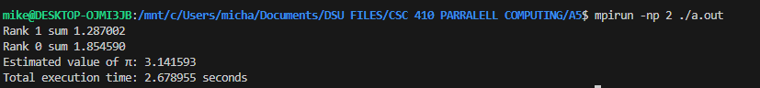

It’s working as expected

|  |  |  |
| --- | --- | --- |
| Integrate | | |
|  | 1 Process | 2 Process | 4 Process | 6 Process |
| Time | 4.65 | 2.67 | 1.38 | 1.04 |